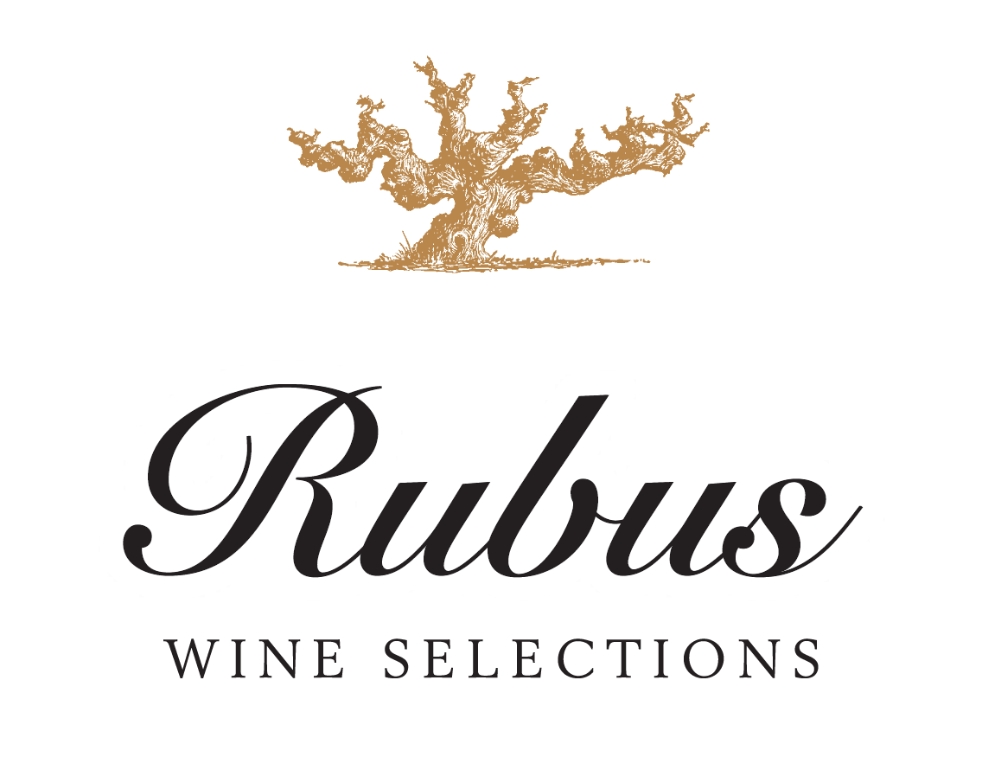

The Rubus Project was created by specialty importer Fran Kysela as a way to source & sell incredible wines at value prices. All wines in this international project are hand-selected by Fran Kysela. Rubus wines are fruit driven, true-to-type values that over deliver. Rubus is a true representation of quality for the consumer at an excellent price.

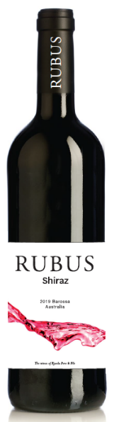
2018 RUBUS SHIRAZ 12/750ml
Source: Australia – Barossa Valley
98% Shiraz & 2% Viognier. The Viognier was co-fermented (50/50) with Shiraz and then back blended with Shiraz before filling to oak. The wine features 15% super premium Shiraz, which was aged in rich American oak coopered in France (more delicate & yielding more elegant, longer tannins). The remaining wine saw American oak, most of which was sourced from the Appalachian mountain range. The coopers say that these barrels add a spicy nose and creamy mid palate (almost like lemon cream).

This richly concentrated Barossa Shiraz is indicative of the style for which Australia's top production region is famous. The wine is dark in color, rich and dense. There are ample tannins balanced by the powerful fruit. You will note the hints of blackberries, mint, and eucalyptus flavors upfront and in the finish.

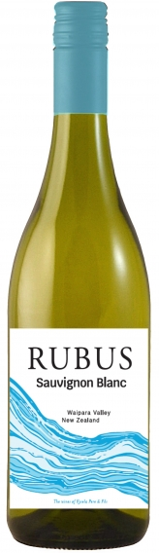
2019 RUBUS SAUVIGNON BLANC 12/750ml
Source: New Zealand – Waipara Valley
100% Sauvignon Blanc aged 2 months on the lees in stainless steel tanks.
This Sauvignon Blanc was produced from grapes grown in the heart of the Waipara Valley, from Church Road, Stirling and Georges Road vineyards. The extended growing season of warm, fine days and cool nights ensured the fruit was harvested in wonderful condition. Following harvest, the fruit was gently pressed, settled and racked to fermentation. The juice was then cool fermented for 21 days and left on lees contact for a further two months prior to blending, light fining, filtering and bottling.
Aromas of gooseberry, lemongrass, boxwood, fresh celery and bready notes on the nose. The palate is dry to taste with juicy gooseberry and citrus flavors forming a light, refreshing medium bodied wine with a tart yet soft lingering finish.

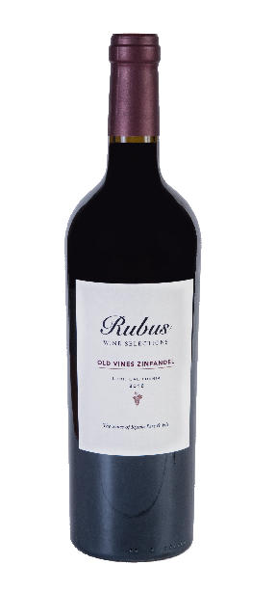
2017 RUBUS OLD VINE ZINFANDEL 12/750ml
Source: United States – Lodi, California
98% Old Vine Zinfandel and 2% Cabernet Sauvignon. Aged for 9 months in French and American oak.
Zinfandel was one of the first grape varieties to be planted in the area during the California Gold Rush, therefore it holds a special place in Lodi’s history as a winegrowing region. The vines are naturally low-yielding due to their age, and they consistently produce high quality fruit.

"Seriously flavorful and appealing, this full-bodied wine virtually overflows with luscious blackberry, strawberry and maple flavors on a broad mouthcoating texture. It has good concentration, breadth and a lingering finish."
-Wine Enthusiast (October 1st 2019), 90 pts

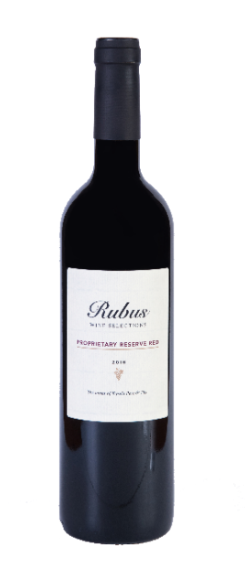
2018 RUBUS PROPRIETARY RED 12/750ml
Source: Spain - Calatayud
90% Garnacha and 10% Syrah. Part of the blend is aged briefly in French oak.
The grapes for Rubus Proprietary Reserve Red are sourced from a mountainous area called SistemaI Ibérico, characterized by its high altitude and loose, stony, nutrient-poor soil. 80% of the vineyards are located at an altitude higher than 800 meters above sea level, planted in goblet (bush vine), with 60% of vines over 50 years old. There is a blend of soil types:
- Gravel, composed of pebbles and boulders coming from alluvium, with good drainage
- Red slate, dry with low fertility
- Darker gray slate, retaining the heat during the day and cooling at night
- Marl composed of limestone and clay, deep soils
- Areas with clay, sandy and limestone soils.
In this blend of 90% Garnacha and 10% Syrah, 70% of the Grenache used is Garnacha Tinta from 35-year-old vines. The remaining Grenache is a mix of Garnacha Peluda (Lledoner Pelut), Garnacha Tintorera and some loose Garnacha Blanca vines. The Syrah, which is mostly planted in trellis with irrigation, contributes color and aromas to the blend.
The resulting blend produces a flavorful wine, rich in blackberry and plum fruits, with aromas of subtle spices, berry and fruitcake.
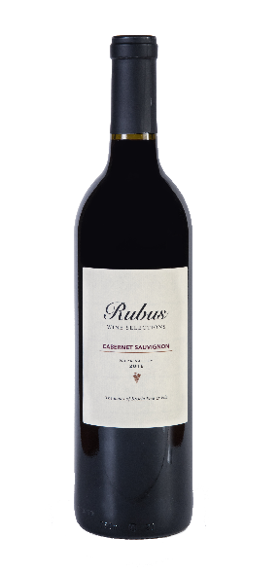

2018 RUBUS NAPA CABERNET SAUVIGNON 12/750ml
Source: United States – Napa Valley, California
100% Cabernet Sauvignon.
Its long finish displays full mature flavors of blackberry, currant and chocolate with just a hint of toasty oak and black cherry. The tannins are refined and polished, allowing the fruit to be the focus.

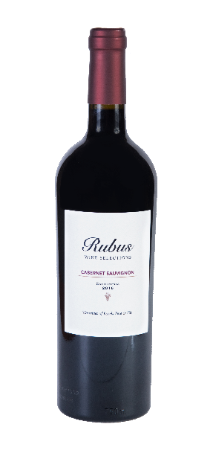

2017/2018 RUBUS AVA CALIFORNIA CABERNET SAUVIGNON 12/750ml
Source: United States – Lodi & Sierra Nevada Hills, California
100% Cabernet Sauvignon, aged 5 months in French oak barrels. 15-year-old vines.
Grapes were picked at premium ripeness. Fermented in static tanks with pump-overs three times per day.
This California Cabernet Sauvignon has rich flavors with a hint of black currant and cherry. The tannins are soft, leading to a smooth finish with a hint of oaked vanilla and a touch of eucalyptus/mint freshness.

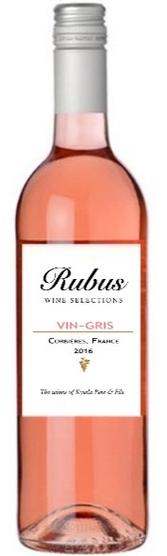

2020 RUBUS VIN-GRIS 12/750ml
Source: France – Languedoc-Roussillon - Corbières
80% Grenache, 10% Carignan, 10% Cinsault. Aged on the lees for 3 months; no oak.
For this special blend for Kysela, the producer devoted extra focus to the pruning technique, lowering yields, sorting the grapes, selecting the tanks & continuing their environmentally conscious approach to vine growing, harvest and winemaking.
Pale pink rose color with salmon hues. Delicate strawberry nose, savory berries and cherries, and a touch of dried herbs and minerality. A classic gris de gris at a great value price.

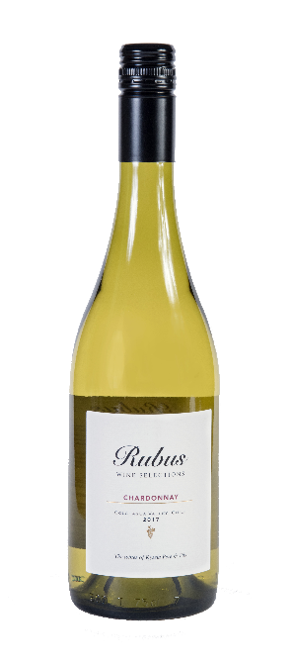
2019 RUBUS CHARDONNAY 12/750ml
Source: Chile – Colchagua Valley
100% Chardonnay. 25% of the wine is aged in American Oak barrels for 3 months.
Sourced from the Colchagua Valley, characterized by its steep slopes of well-drained granite soils and irrigated by the Tinguiririca River, which bring clear melt water from the Andes. Sauvignon Blanc is grown in the cooler western part of the valley.
Grapes are harvested in the morning to avoid high temperatures & gently pressed at the winery. 25% of the wine goes into American Oak barrels for 3 months.
Attractive yellow color with some green tones. Its intense varietal character reminds one of ripe fruits like pineapple, with notes of melon and honey well harmonized with oak. Full, rich and buttery.

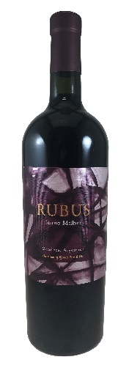
2018 RUBUS ICONO MALBEC 6/750ml
Source: Argentina – Uco Valley – Paraje Altamira
100% Malbec. Aged 12 months in 225-liter French Oak Barrels.
Sourced from ten-year-old vines in Paraje Altamira. Gentle winemaking with natural yeast and long maceration at controlled temperatures yield purity and richness in this wine. Slight filtration before bottling.

"Full ripeness on nose is reflected through malty aromas of cassis, raisin and prune, while this feels lush on the palate. Blackberry, raisin and oak-based café mocha flavors play out on a smooth finish with soft tannins. - MICHAEL SCHACHNER"
- Wine Enthusiast (December 2020), 90 pts

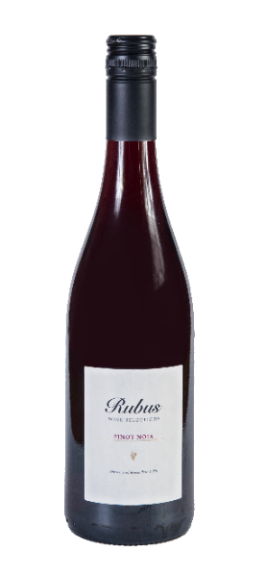

2018 RUBUS PINOT NOIR 12/750ml
Source: Italy – Lessini Hills, Veneto
100% Pinot Noir. 30% of the wine was aged for 4-5 months in French Oak barrels.
Grapes are sourced from the Lessini hills in the Colli Berici, where the cold nights allow the aromatic compounds in the grapes to develop. The vines, 20 years old on average, are planted on calcareous soils of volcanic origin. The grapes were harvested, destemmed, crushed and then cool soaked for 24 hours. Maceration on the skins took place before fermentation at temperatures of up to 22°C. Following malolactic fermentation, 30% of the wine was aged in oak for 4-5 months prior to bottling.
Nice garnet and red color. Expressive and charming on the nose with cherry and blackberry aromas. On the palate, the wine has a nice spicy note. The length to the finish is round and long.

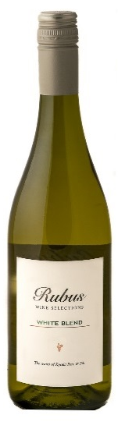

2019 RUBUS WHITE BLEND 12/750ml
Source: Southern France
80% Colombard, 10% Ugni Blanc, 10% Gros Manseng. Aged on the lees for 3 months; no oak. Agrilo-calcaire (limestone & clay) soil.

Fresh, clean and lively with intense exotic fruit aromas. Crisp, clean and zesty in the mouth, it offers delicate flavors of citrus fruit and grapefruit, and a long lingering finish.

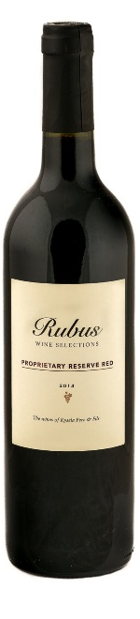
2014 RUBUS PROPRIETARY RESERVE RED 12/750ml
Source: South Australia
44% Rubired, 31% Durif and 25% Shiraz; aged 9 months in oak (French & American).
Rubired is a cross between Tinto Cao and Alicante Ganzin (which is itself a cross between Alicante Bouschet and Aramon Rupestris Ganzin). It is known for being particularly adapted to the hot climate and producing dark wines, as the color is not only coming from the grape's skin, but also from the grape juice itself. It was developed in 1958 by H.P. Olmo of the University of California Davis.
Durif, also known as Petite Sirah, is also a cross of two different grape varietals: Syrah and Peloursin. It was created by French botanist François Durif in 1860 while keeping Syrah and Peloursin plants under the same roof; it happened from a natural process called "cross-pollination." The grape itself is known for its very aromatic, plummy character.
Shiraz, which we all know for being the most recognized grape varietal of Australia, brings some minty, spicy and fruity characteristics to the wines.
Deep, dark ruby color with aromas of blue fruit, confectionery and subtle licorice characters. Thick luscious palate with good structure and soft finish.

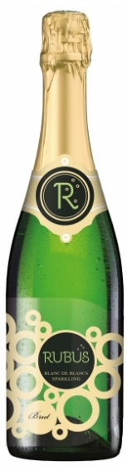

NV RUBUS SPARKLING BRUT BLANC DE BLANCS 12/750ml
Source: France
30% Ugni Blanc, 30% Airen, 30% Colombard and 10% Chardonnay. From 20-year-old vines on clay/limestone chalk soil.
Machine harvest. The base wine is fermented at a low temperature. The second fermentation takes place at 14°C for 2 weeks, followed by dosing.
Elegant pale yellow color with fine bubbles. Floral and fruity on the nose, with aromas of fresh butter and cake. On the palate, the wine is crisp and harmonious - a delightful sparkling wine.

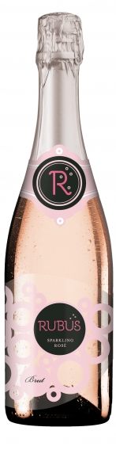

NV RUBUS SPARKLING BRUT ROSÉ 12/750ml
Source: France
60% Tempranillo & 40% Bobal. From 20-year-old vines on clay/limestone chalk soil.
Machine harvest. The base wine is fermented at a low temperature. The second fermentation takes place at 14°C for 2 weeks, followed by dosing.
Stunning salmon-pink hues. The nose is intense and fine, dominated by notes of red berries. On the palate, the combination of fine bubbles and delicate aromas produces a delightfully light and silky rosé.

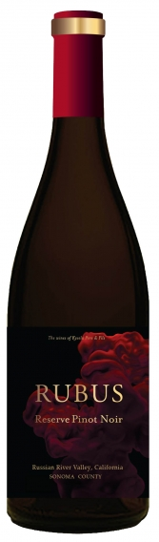

NEW FOR 2021!
2018 RUBUS, RESERVE PINOT NOIR, RUSSIAN RIVER 12/750ml
Source: United States – California - Russian River Valley
Pinot Noir, the ancient grape of the Duchy of Burgundy, has long been the ‘Holy Grail’ of the wine business. Elusive, and terroir transparent, there are few places where this grape does well…and the Russian River Valley on the Sonoma Coast is one of them.
This wine shows complexity with raspberry and cherry notes that dance on the tongue.

NEW FOR 2021!
2020 RUBUS, RESERVE PINOT NOIR, RUSSIAN RIVER 12/750ml
Source: United States – California - Russian River Valley
Pinot Noir, the ancient grape of the Duchy of Burgundy, has long been the ‘Holy Grail’ of the wine business. Elusive, and terroir transparent, there are few places where this grape does well…and the Russian River Valley on the Sonoma Coast is one of them.
This wine shows complexity with raspberry and cherry notes that dance on the tongue.

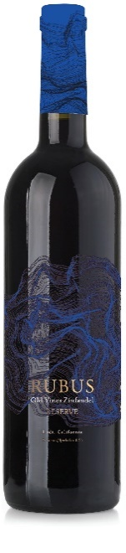

NEW FOR 2021!
2019 RUBUS, RESERVE OLD VINE ZINFANDEL, LODI 12/750ml
Source: United States – California – Lodi
This premium Lodi Zinfandel exhibits spicy berry fruit flavors typical of head trained Zinfandel vines from the top growing areas of Lodi, CA. Rich, juicy & complex. This medium-bodied red pairs best with grilled meats and cheeses.

